# *Assignment*

# Lab 10 – Code Review and Quality

**Htno :** 2503A52L09

## Task 1 – Syntax and Logic Errors

**Original Code:**

def calc_average(marks):  
total = 0  
for m in marks:  
total += m  
average = total / len(marks)  
return avrage  
marks = [85, 90, 78, 92]  
print("Average Score is ", calc_average(marks)

**Issues Identified:**

- Improper indentation.  
- Typo in variable name 'avrage'.  
- Missing closing parenthesis in print statement.  
- No input validation (possible ZeroDivisionError).  
- No docstring or type hints.

**Fixed Code + Output:**

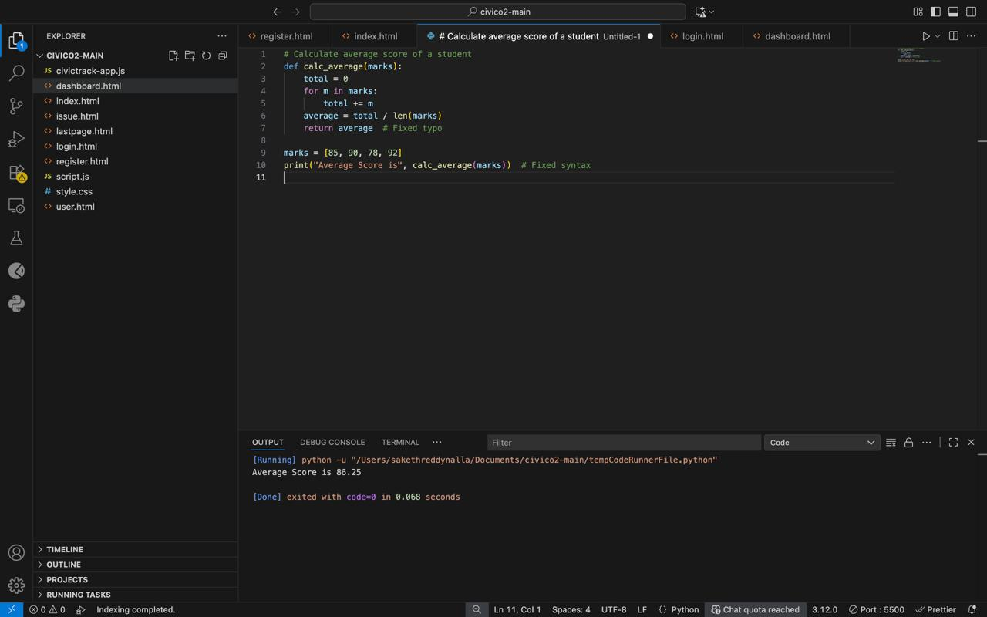

## Task 2 – PEP 8 Compliance

**Original Code:**

def area_of_rect(L,B):return L*B  
print(area_of_rect(10,20))

**Issues Identified:**

- Function parameters use uppercase letters (should be lowercase and descriptive).  
- One-liner function reduces readability.  
- Missing docstring and type hints.  
- No space after commas.

**Refactored Code + Output:**

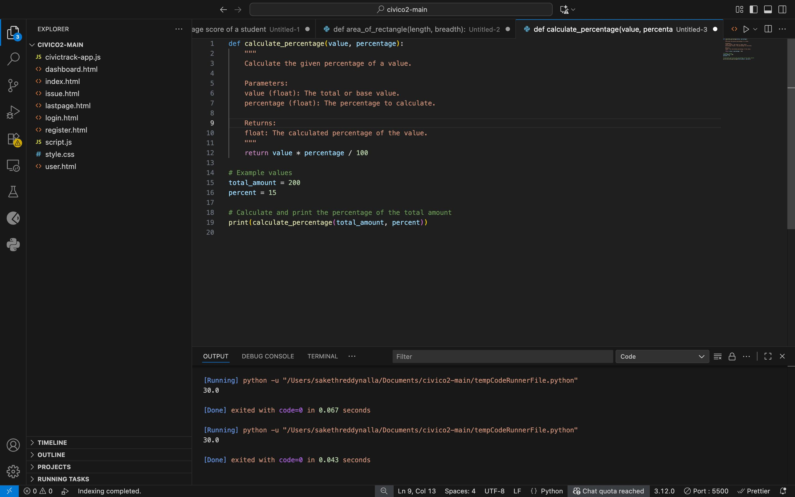

## Task 3 – Readability Enhancement

**Original Code:**

def c(x,y):  
return x*y/100  
a=200  
b=15  
print(c(a,b))

**Issues Identified:**

- Non-descriptive function name ('c').  
- Non-descriptive variable names ('a', 'b').  
- No docstring or inline comments.  
- Missing indentation and poor formatting.

**Refactored Code:**

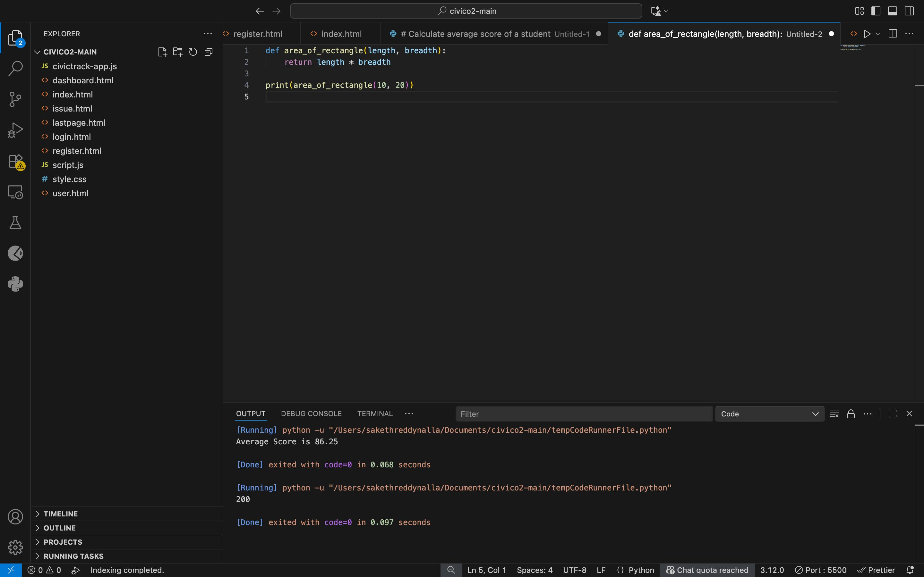

## Task 4 – Refactoring for Maintainability

**Original Code:**

students = ["Alice", "Bob", "Charlie"]  
print("Welcome", students[0])  
print("Welcome", students[1])  
print("Welcome", students[2])

**Issues Identified:**

- Repeated print statements (not scalable).  
- No modularity, cannot handle larger student lists.  
- No function abstraction.  
- Harder to maintain and reuse.

**Refactored Code + Output:**

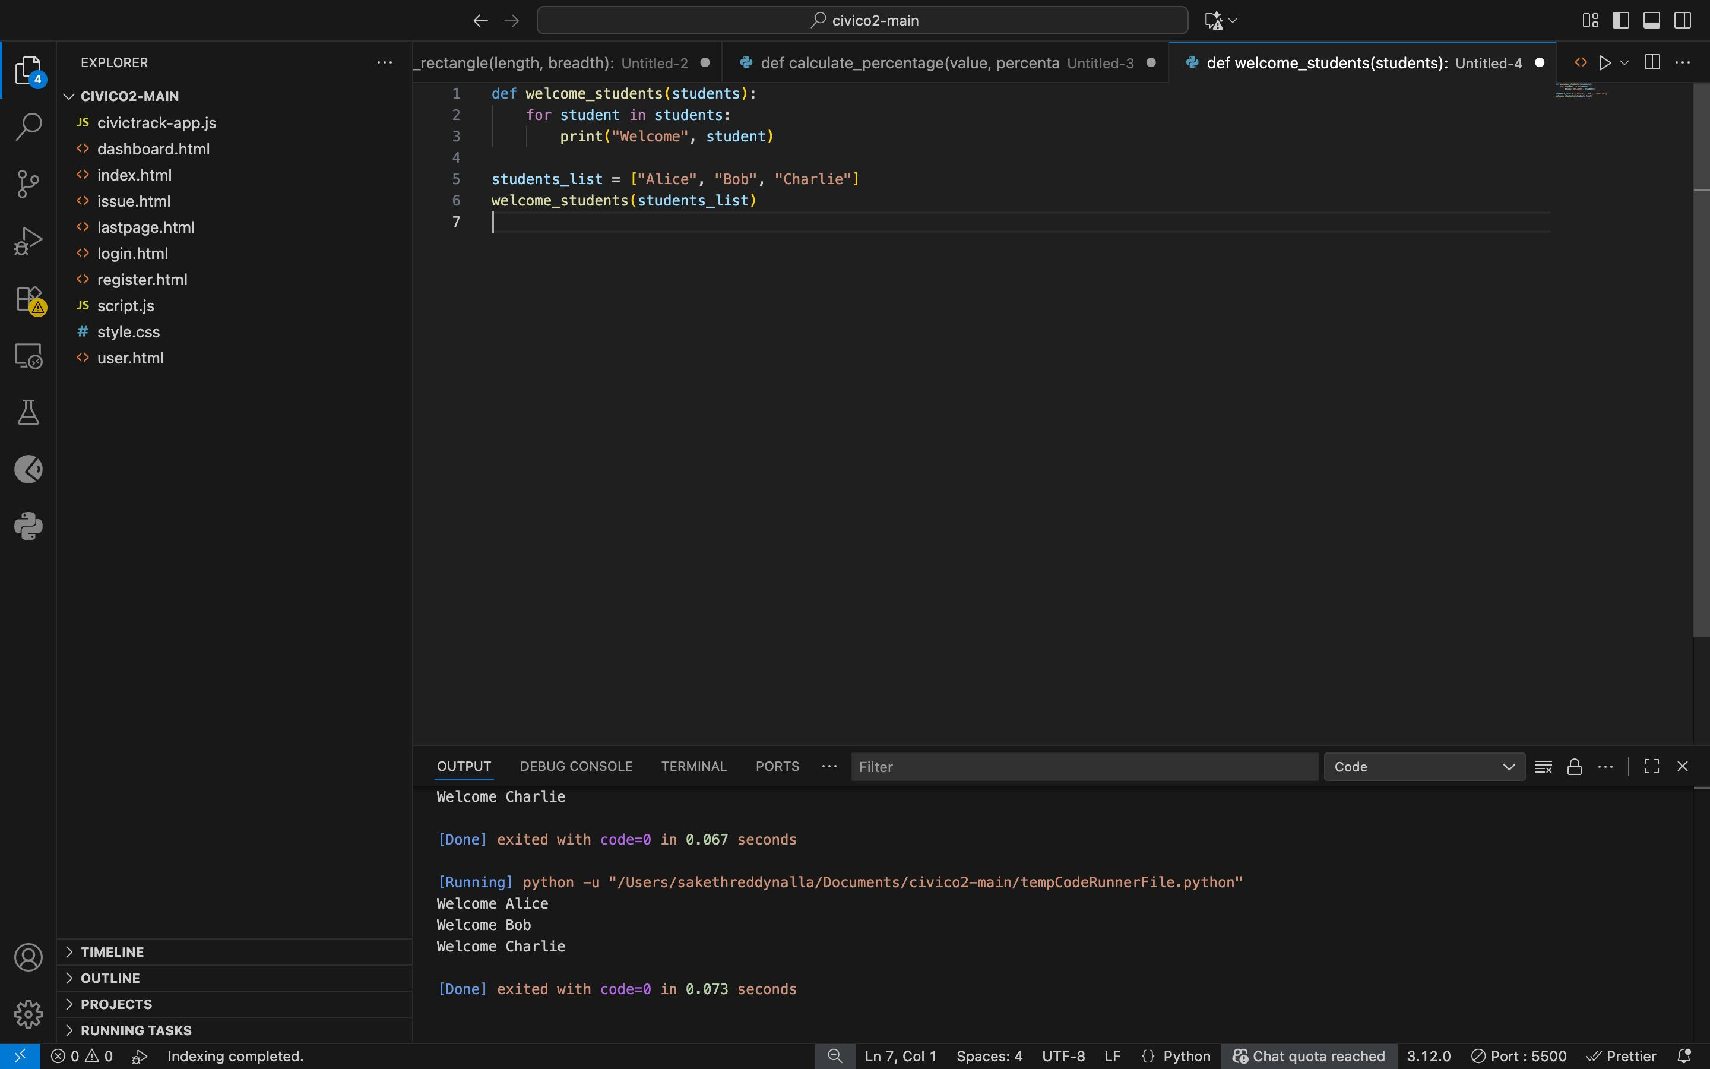

## Task 5 – Performance Optimization

**Original Code:**

nums = [i for i in range(1,1000000)]  
squares = []  
for n in nums:  
 squares.append(n**2)  
print(len(squares))

**Issues Identified:**

- Inefficient loop with append (slower than list comprehension).  
- Creates unnecessary intermediate list 'nums'.  
- High memory usage for large ranges.  
- Not scalable.

**Refactored Code + Output:**

## 

## Task 6 – Complexity Reduction

**Original Code:**

def grade(score):  
 if score >= 90:  
 return "A"  
 else:  
 if score >= 80:  
 return "B"  
 else:  
 if score >= 70:  
 return "C"  
 else:  
 if score >= 60:  
 return "D"  
 else:  
 return "F"

**Issues Identified:**

- Overly nested if-else statements (hard to read).  
- Poor maintainability.  
- No type hints or docstring.

**Refactored Code with elif + Output:**

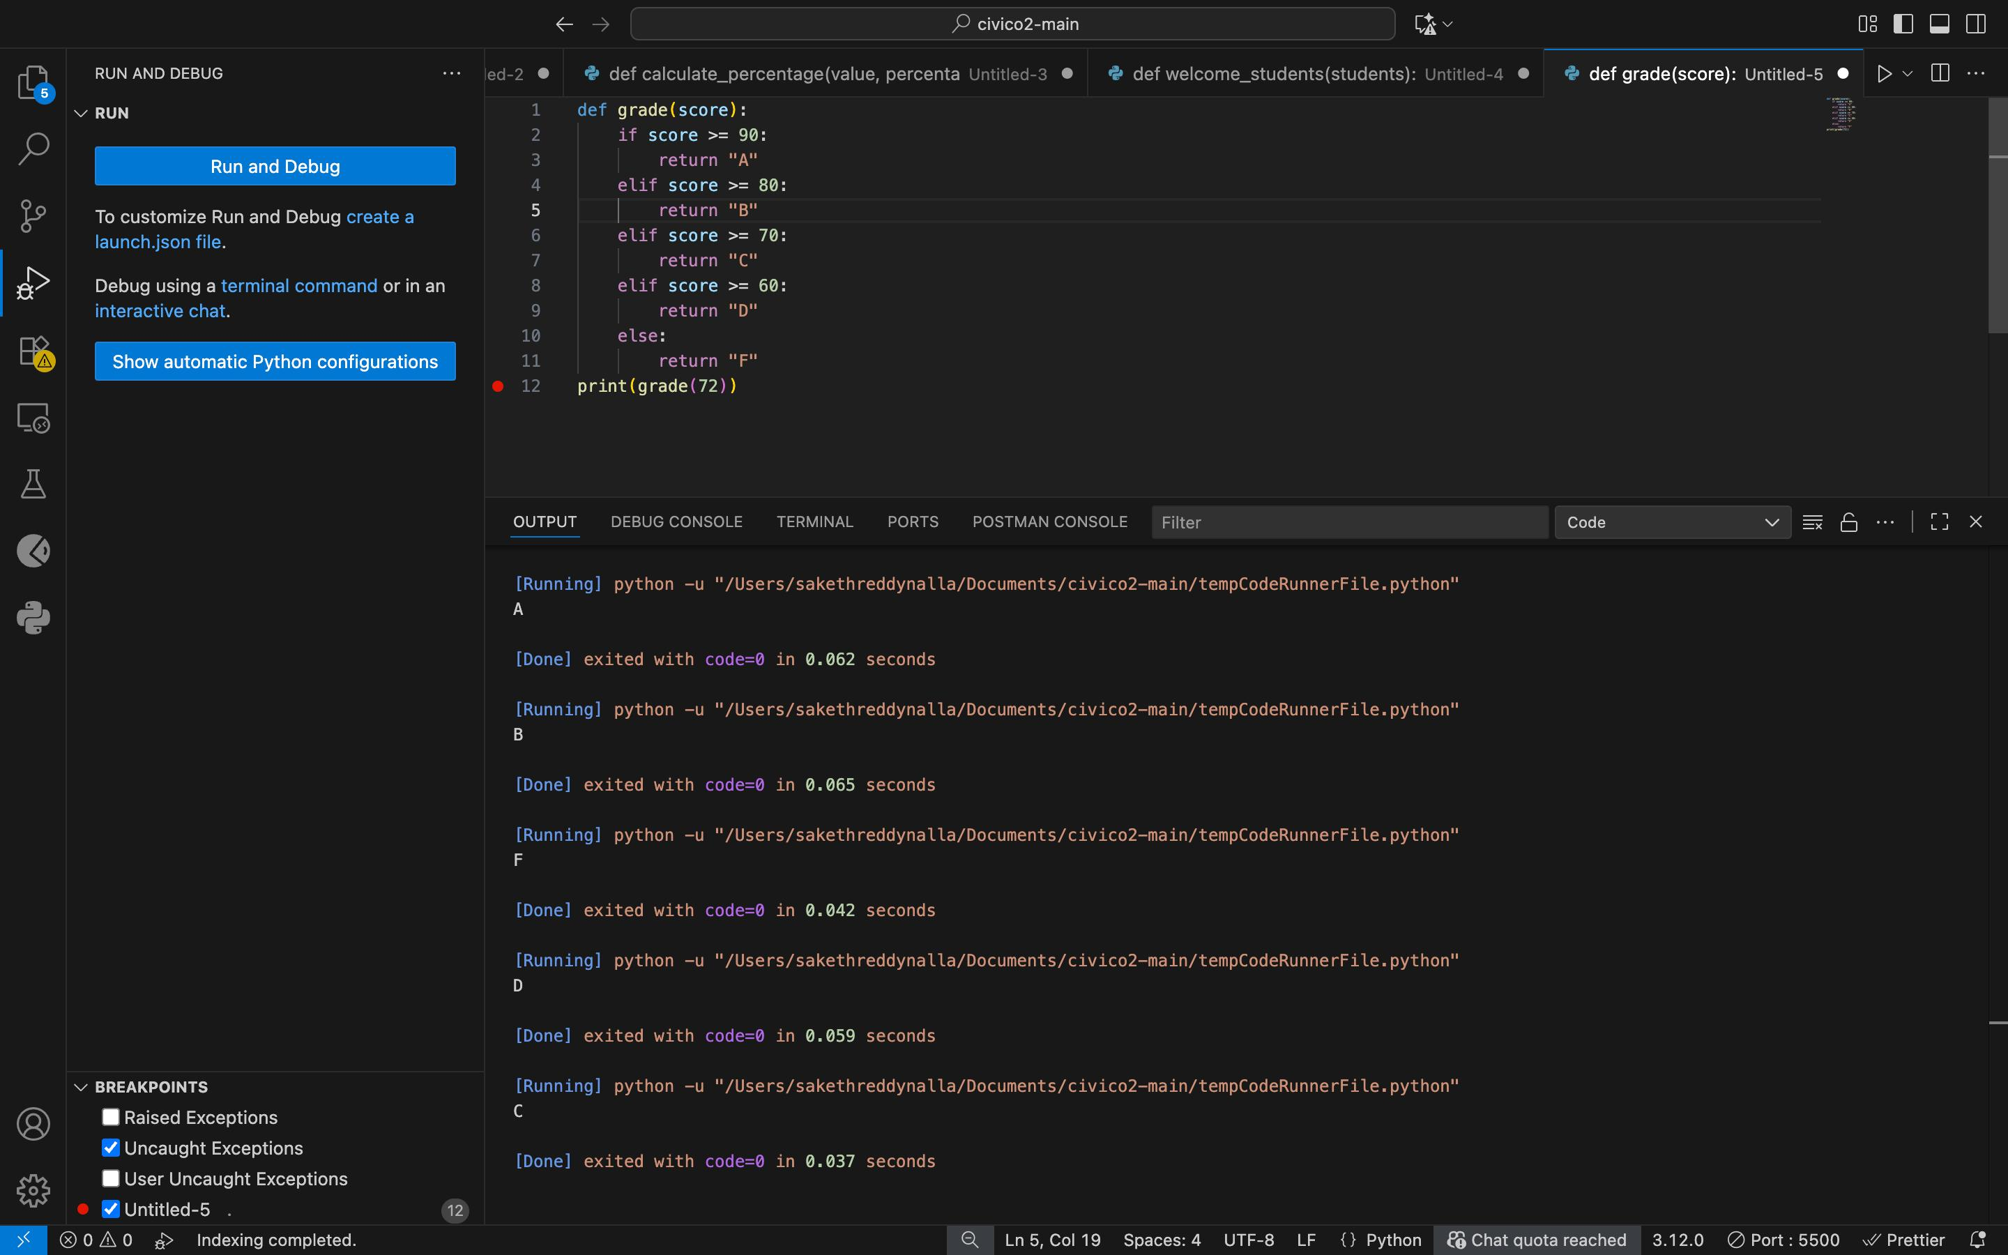

**Observation :**

* The tasks highlighted common issues in Python code, including syntax, logic, readability, and maintainability problems.
* Applying PEP 8 guidelines improved code structure, naming conventions, and overall clarity.
* Refactoring repetitive and complex logic into functions enhanced modularity and scalability.
* Performance optimization using list comprehensions, generators, and NumPy reduced execution time and memory usage.
* Overall, AI-assisted code review improved code quality, making it cleaner, efficient, and easier to maintain.